

* Team members:  
  Jordan Anger  
  Jasper Everitt

Joseph Portera

Anthony Sedore

* Advisor’s name:  
  Dr. Wilfrido Moreno

EEL4914 Fall 2024

Harsh Environment Sensor PCB

FINAL REPORT

1. EXECUTIVE SUMMARY 3

1.1 PROJECT OVERVIEW 3

1.2 PURPOSE AND SCOPE OF THIS SYSTEM REQUIREMENTS DOCUMENT 3

1.3 DEFINITIONS, ACRONYMS, AND ABBREVIATIONS 4

1.4 REFERENCES 5

2. PRODUCT/SERVICE DESCRIPTION 6

2.1 PRODUCT CONTEXT 6

2.2 ASSUMPTIONS 7

2.3 CONSTRAINTS 7

2.4 DEPENDENCIES 8

3. REQUIREMENTS 9

3.1 FOLLOWING AREAS SHOULD BE CONSIDERED FOR FUNCTIONAL REQUIREMENTS 9

3.1.1 User Interface Requirements 9

3.1.2 Performance 9

3.1.3 Capacity 9

3.1.4 Availability 9

3.1.5 Latency 10

3.1.6 Manageability/Maintainability 10

3.1.7 Monitoring 10

3.1.8 Maintenance 10

3.1.9 Systems Interfaces 10

3.2 SYSTEM REQUIREMENTS MATRIX 10

4. USER SCENARIOS/USE CASES 11

5. ANALYSIS MODELS 12

5.1 SEQUENCE DIAGRAMS 12

5.2 DATA FLOW DIAGRAMS 12

5.3 STATE-TRANSITION DIAGRAMS 13

5.4 SWAP 13

5.5 SYSTEM PERFORMANCE 13

6. PROJECT RISK 14

7. STANDARDS 14

8. ENGINEERING ETHICAL RESPONSIBILITY 16

9. SAFETY 17

10. CONCLUSIONS 18

11. WORK DIVISION 19

12. Appendix 19

# 1. EXECUTIVE SUMMARY

## 1.1 PROJECT OVERVIEW

## The Harsh Environment Sensor Board is an innovative hardware and software solution designed to monitor and report data from various environmental sensors to remote operators. Sponsored by Software Logistics, this project focuses on improving an existing Printed Circuit Board (PCB) design to meet rigorous requirements for operation in extreme environmental conditions. These include exposure to extreme temperatures, high vibrations, and moisture, among others.

## Our product is targeted at clients requiring reliable remote monitoring solutions in critical applications such as heavy machinery, remote installations, and industrial systems. The sensor board collects telemetry data and transmits it over a cellular network to Software Logistics' NuvIoT platform, enabling real-time monitoring and data analysis.

## Key Achievements

## Developed two fully functional prototypes of different design revisions (Rev1 and Rev2) to iteratively refine the system’s performance and address technical challenges.

## Ensured seamless integration of hardware components, including the ESP32 microcontroller, cellular communication modules, and a variety of onboard sensors.

## Designed the PCB to function reliably within a temperature range of -30°F to 150°F and withstand harsh environmental factors such as vibrations and impacts.

## Implemented features for battery management, supporting both Lithium-Ion and Lithium-Polymer rechargeable batteries, with operational capabilities extending to 7 days on a single charge.

## Impact and Benefits

## The Harsh Environment Sensor Board offers a robust and scalable solution for data collection and remote monitoring in challenging environments. By emphasizing reliability, modularity, and ease of integration, the product addresses a critical need in industrial automation and remote sensing applications.

## 1.2 PURPOSE AND SCOPE OF THIS SYSTEM REQUIREMENTS DOCUMENT

**Purpose:** The purpose of this System Requirements Document is to provide a comprehensive overview of the Harsh Environment Sensor Board project, detailing its objectives, technical specifications, and performance requirements. This document serves as a guideline for stakeholders, ensuring clarity and alignment throughout the design, development, and implementation phases.

**SCOPE**

Objectives and performance standards for sensor interface and data communication.  
  
Development of the Printed Circuit Board (PCB) design for the Harsh Environment Sensor Board.  
  
Integration of cellular data transmission capabilities for remote monitoring.

•Functional and non-functional requirements of the system

•Risk analysis, safety considerations, and adherence to relevant engineering standards.

**Out of Scope**

The following items in phase 2 of Harsh Environment Sensor Board are out of scope:

• Designing front end software user interface for clients

• Working with clients to integrate custom sensors with PCB

• Support for non-cellular data transmission methods.

• Battery lifespan exceeding the current scope of 7 days.

## 

## 1.3 DEFINITIONS, ACRONYMS, AND ABBREVIATIONS

PCB – Printed Circuit Board

LiPo – Lithium Polymer Battery

Li-ion – Lithium Ion Battery

IoT – Internet of Things

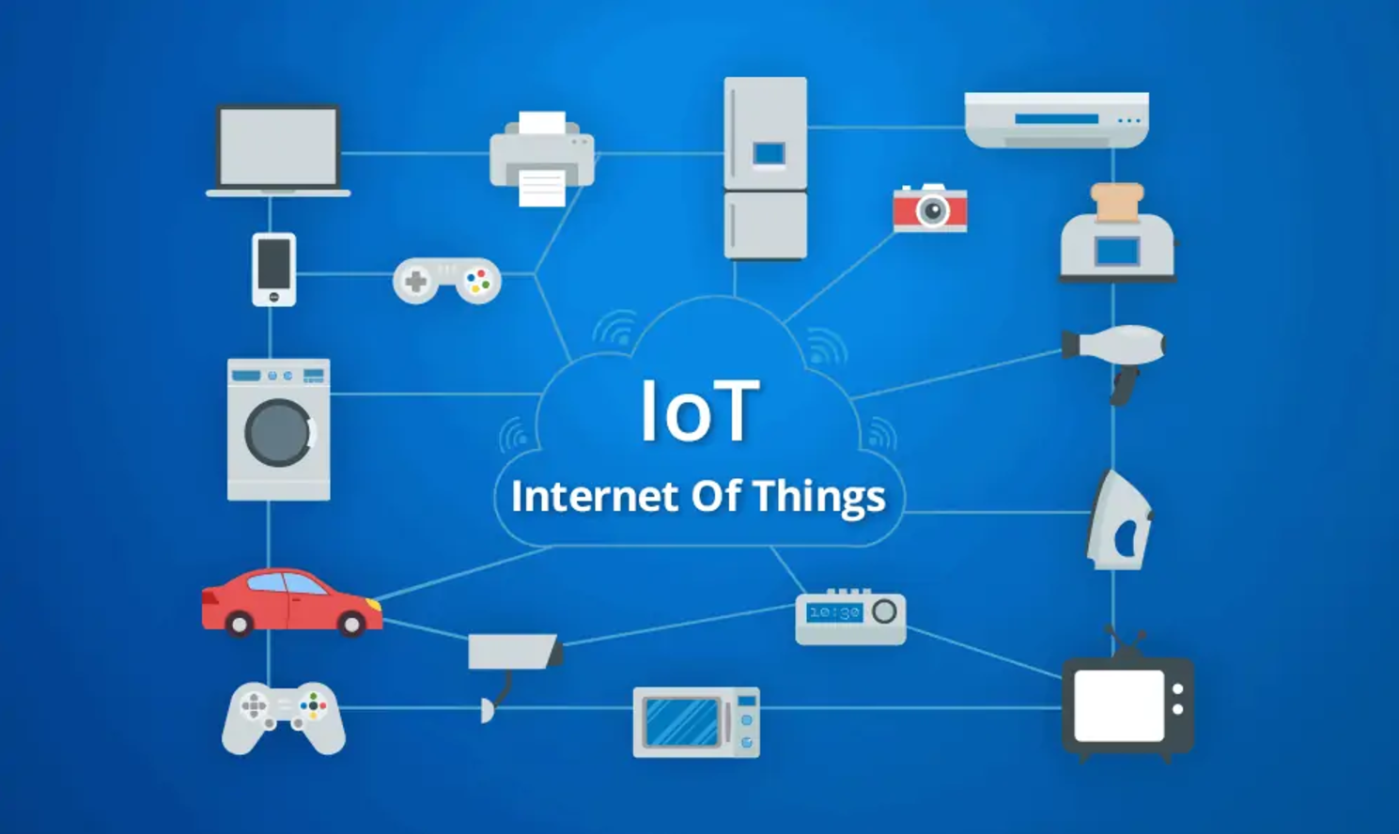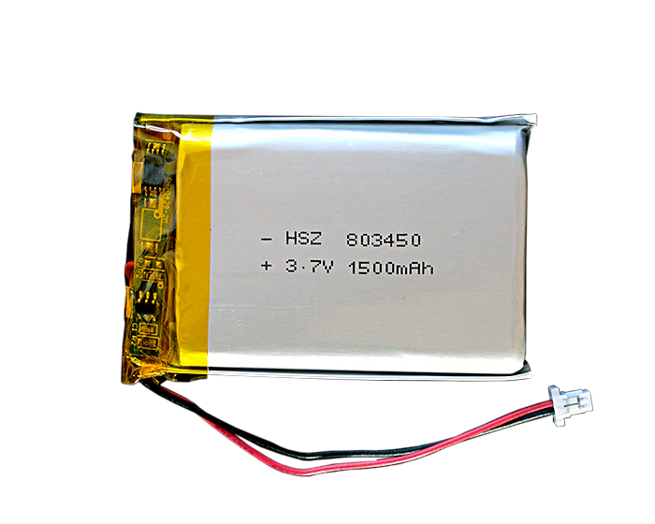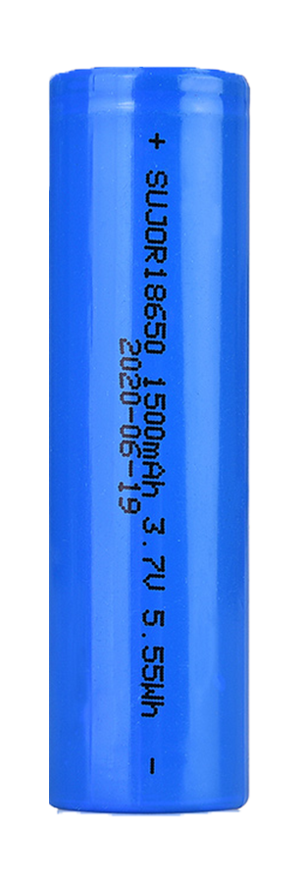

## 1.4 REFERENCES

• Guidance from our sponsor’s advisor

• EagleCad Manuals: http://eagle.autodesk.com/eagle/documentation

• Visual Basic Studio: https://learn.microsoft.com/en-us/visualstudio/windows/?view=vs-2022

• NuvIoT - https://www.nuviot.com/

• MQTT - <https://mqtt.org/>

# 2. PRODUCT/SERVICE DESCRIPTION

## 2.1 PRODUCT CONTEXT

The Harsh Environment Sensor Board is designed to be used as part of larger monitoring systems that can be attached to different vehicles and structures. It is an independent and self-contained system powered by its own battery and microcontroller that can send its temperature data through cellular transmission. A black rectangular object with a circuit board

Figure 1: 3D Model of Harsh Environment Sensor Board

Figure 2 Harsh Environment Sensor Board System Diagram

## 2.2 ASSUMPTIONS

•Cell connection is reliable from the installation location of the unit

•Assume the product will usually run with 24v power supply keeping the battery charged

•Typical user knows best way to configure external sensors for their application

•Typical user will be unable to perform maintenance. Only remove/replace unit.

## 2.3 CONSTRAINTS

•3.5’ x 3.5’ Size or 4’ x 4’ Size

•Battery (working for up to 7 days)

•Withstand temperature range from –30° to 150° degrees Fahrenheit

•Withstand a variety of harsh environmental conditions

## 

## 2.4 DEPENDENCIES

The successful operation of the Harsh Environment Sensor Board relies on several key dependencies:

1. **Power Supply:**
   * The product requires a stable power source, either through an onboard rechargeable 18650 Lithium-Ion battery or an external 24V DC power input. The battery must be capable of supporting the system for up to 7 days without recharging.
2. **Cellular Connectivity:**
   * The product depends on a reliable 4G LTE cellular network to transmit data to the NuvIoT platform. Without consistent cellular service, real-time monitoring and reporting capabilities are compromised.
3. **Environmental Sensors:**
   * The board requires accurate and reliable sensors to measure environmental conditions such as temperature and vibration. The compatibility of these sensors with the PCB is critical for seamless operation.
4. **Firmware Integration:**
   * The system relies on pre-programmed firmware for the ESP32 microcontroller to manage data collection, processing, and transmission. Any firmware updates must be deployed via the USB interface.
5. **Cloud Platform:**
   * Integration with Software Logistics’ NuvIoT platform is necessary for storing, analyzing, and visualizing transmitted data. The platform must support the MQTT protocol for low-latency data communication.
6. **Component Availability:**
   * The project is dependent on the timely procurement of electronic components such as the ESP32, SIM7080G module, and other critical parts. Supply chain disruptions could delay development and deployment.
7. **Mechanical Enclosure:**
   * The physical design of the board requires a robust and waterproof ABS plastic enclosure to protect components from environmental damage. The dimensions and design of this enclosure directly influence PCB layout and component placement.
8. **Testing Equipment:**
   * The development process requires access to testing tools such as multimeters, oscilloscopes, and environmental simulation chambers to validate performance under harsh conditions.
9. **Engineering Standards Compliance:**
   * The product depends on adherence to industry standards (e.g., IEEE 802.11 for Wi-Fi, 3GPP for LTE, and ISO 1451 for sensor interfaces) to ensure compatibility and regulatory compliance.
10. **Team Collaboration:**
    * Successful completion of the project is reliant on effective collaboration among team members, sponsors, and advisors to address technical challenges and ensure alignment with project goals.
11. **Software Development Tools:**
    * Tools such as Visual Studio Code, EagleCAD, and other PCB design software are essential for coding, circuit design, and system debugging.

# 3. REQUIREMENTS

The requirements for this product consists of:

• Product must be able to operate up to 150° Fahrenheit

• Product must be able to operate down to -30° Fahrenheit

• Product must read environmental temperature data with sensor

• Product must read board temperature

• Product must communicate with external sensors

• Product must transmit data over cellular transmission

• Product must operate off 18650 Li-ion battery or LIPO Battery

• Product must have battery charging capability

• Product must operate for a week on battery power

## 3.1 FOLLOWING AREAS SHOULD BE CONSIDERED FOR FUNCTIONAL REQUIREMENTS

## 3.1.1 User Interface Requirements

We will use an already developed mobile application/platform, NuvIOT, for our user interface that is able to obtain the data emitted by the harsh environment sensor board over cellular transmission.

This user interface will be easy to use and allow a user to efficiently analyze and read the data from the harsh environment sensor board remotely. The reporting over cellular data will be optimized for low packet size using the MQTT protocol, which is an industry standard in IoT devices.

## 3.1.2 Performance

In terms of performance, our mobile application will be able to handle 1-2 users who can read the data transmitted by the board. It will be able to handle 1-4 different types of data and information that is transmitted to it.

## 3.1.3 Capacity

Capacity for multiple users (Engineers, typical consumers), Software should be able to handle multiple users using the telemetry system.

## 3.1.4 Availability

• Sensor is working 24/7

• Works perfectly in a Harsh Environment

• Someway to identify board without power or when power outage occurs

• Battery lasts for 30 days

• Withstand environmental obstructions (vibrations, shock)

• Reliable in many different environments

• Report data through cellular signals

## 3.1.5 Latency

The product must update the data sent every 1 second.

## 3.1.6 Manageability/Maintainability

The product is managed via web interface through the NuvIOT platform provided by Software Logistics.

## 3.1.7 Monitoring

The product will have failure and error monitoring to tell the user when certain parts are not working as intended. Most monitoring occurs on the server side of the telemetry, which is external from the operation of the board.

This monitoring will be done through the NuvIOT platform provided by Software Logistics.

## 3.1.8 Maintenance

The product will be able to be taken outside of the insulating container for maintenance. Each of the sensors and systems will be connected to a PCB that can be taken off if necessary.

Whenever the LIPO battery goes bad, it will be able to be replaced after being detected. Can either be soldered on directly or put in a battery case.

## 3.1.9 Systems Interfaces

1. Interface with mobile application through cellular transmission of its data.

2. USB interface for reprograming firmware, configuration, and system monitoring/debugging.

3. Sensor interface for reading various types of external sensors.

## 3.2 SYSTEM REQUIREMENTS MATRIX

| Req# | Function | Requirement | Comments | Date Rewd | SME /Faculty Reviewed / Approved |
| --- | --- | --- | --- | --- | --- |
| 1 | ME | Operate in temperatures between -30 and 150°F. | Environment Temperature | 2/28/24 |  |
| 2 | ME | Enclosure should be watertight, and resistant to impacts | PCB physical design is constrained to enclosure design. | 03/04/24 |  |
| 3 | Software | System should run continuously in all planned environments | Software design must maximize unit HA (High Availability) | 03/04/24 |  |
| 4 | EE | System can communicate data through cellular transmission | Software and Hardware can communicate cellularly | 03/06/24 |  |
| 5 | EE | Rechargeable onboard battery | Battery that can last and be recharged | 03/06/24 |  |
| 6 | EE | System should be able to interface with external sensors |  | 03/18/24 |  |
| 7 | ME | PCB Size of 3.5 in x 3.5 in |  | 3/18/24 |  |
| 8 | Software | Detect failures and report failure type |  | 3/18/24 |  |
| 9 | Software | Microcontroller reprogrammable through USB | Access for engineer to update/change firmware for sensor board | 3/18/24 |  |

# 4. USER SCENARIOS/USE CASES

Heavy machinery is used in many industries to serve critical roles within many system processes. Machinery used to generate electricity, in manufacturing plants, water control, and farming all generate substantial amounts of heat and often operate within harsh environments. The surveillance of these machines can avoid costly shutdowns, maintain optimal conditions, and relay feedback for remote monitoring. The locations of these machines can be in challenging environments for embedded solutions due to vibration, extreme temperature, not near wall outlets, not near Wi-Fi, and inaccessible/hard-to-reach spots for workers.



The harsh environment sensor board is a board designed to withstand these extreme temperatures, remoteness, and vibration in a reliable, low maintenance solution. One area in which the board is targeted for is to be placed in rooms with heavy machinery to monitor temperatures remotely through cellular transmission. Our board is also designed with the goal of providing an engineer the capabilities to implement solutions for specific use cases (Like a Swiss army knife) to the environment and the sensors necessary to meet client requirements.



# 5. ANALYSIS MODELS

To analyze our system, we use a variety of methods and approaches to finalize our product. We conducted trade studies to compare different options and parts for our PCB and enclosure to achieve our requirements and goals. To simulate the PCB design, we conducted tests in our software to test speed, efficiency, and accuracy of how the different parts of our system work together.

## 5.1 SEQUENCE DIAGRAMS

## 5.2 DATA FLOW DIAGRAMS

## 5.3 STATE-TRANSITION DIAGRAMS

## 5.4 SWAP

SIZE - 5.4.1

WEIGHT - 5.4.2

POWER - 5.4.3

•PCB Size - 2.3” x 3.6”

•Enclosure – 7.87" x 4.72" x 2.95"

•Two 18650 Cells: 45g * 2 = 90g

•Weight of 4-Layer PCB & Components = 73 g

•Waterproof ABS Plastic Enclosure = 43 g

•Total Weight = 206 g (0.45 pounds)

•Capacity of 14 Wh for one 18650 Cell = 14 Wh * 2 = 28 Wh

•ESP32 Microcontroller sleep energy consumption of 0.8mA, 240mA transmitting WiFi

•Estimated Power Consumption of 1w, Battery Lifespan of ~1 Days

•Transmission Time of 60 seconds per hour

SWAP

## 5.5 SYSTEM PERFORMANCE

• One day on battery power with full capabilities or could be extended to 2 days in a low power state.

• We measured the system performance by conducting simulations and math formulas comparing power usage every hour to battery capacity.

# 6. PROJECT RISK

|  |  |
| --- | --- |
| Component and PCB prototype delivery not arriving on time. | Finalize bill of materials and component selection so orders can be placed sooner. |
| Component shortages | Choose parts in design that have lots of available stock. |
| Order parts while components are still in stock and check the possibility of shortages occurring. | In bill of materials identify possible interoperable alternatives |
| Assembly of prototype | * Issues resulting from hand assembly of PCB such as poor soldering, incorrect alignment and placement of components can produce problems that can be mitigated by following soldering standards and use of multimeter to check electrical connections. * Make sure to use fully functional pick and place machines for PCB design to avoid prototype assembly problems. |
| Failure of cellular data transmission | PCB design has an interface that allows user to directly obtain data from the board instead of needing cellular communication. |
| Sensor Interface Accommodations | PCB will be designed to fit standard sensor interface designated by Software Logistics and will not support universally any sensor. |
| PCB doesn’t work as intended. | * Conduct extensive analysis of systems within the board and plan to have time for additional PCB to be ordered. * Verification for correct use of different components using data sheets. |

# 7. STANDARDS

The design and development of the Harsh Environment Sensor Board adhere to several engineering standards to ensure reliability, compatibility, and regulatory compliance. These standards influence the board's design choices and functionality in the following ways:

**7.1 IEEE 802.11 (Wi-Fi Standards)**

* **Relevance**: Ensures compatibility with existing wireless communication networks and guarantees reliable data transmission in environments with potential interference.
* **Design Influence**:
  + The ESP32 microcontroller was selected for its compliance with IEEE 802.11 standards, supporting Wi-Fi connectivity for debugging and future expansion.
  + Designed the PCB layout to optimize antenna placement and minimize signal loss.

**7.2 3GPP Release 8 and Beyond (4G LTE Standards)**

* **Relevance**: Governs the cellular communication protocols necessary for transmitting data via the 4G LTE network.
* **Design Influence**:
  + Integrated the SIM7080G LTE module, ensuring adherence to 3GPP LTE standards for efficient data communication.
  + Verified that the module supports low-power operation for long-term use in remote environments.
  + Designed appropriate power regulation circuits to meet the module’s voltage and current requirements.

**7.3 IEEE 1451 (Smart Sensor Standards)**

* **Relevance**: Standardizes communication between sensors and data acquisition systems, ensuring interoperability.
* **Design Influence**:
  + Ensured sensor interfaces conform to the IEEE 1451 standard to support potential future upgrades or replacements with compatible sensors.
  + Added provisions for analog and digital signal inputs to maximize sensor compatibility.

**7.4 USB 3.0 Standards**

* **Relevance**: Provides a reliable and fast interface for reprogramming firmware and debugging the microcontroller.
* **Design Influence**:
  + Included a USB interface on the board, following the USB 3.0 standard for compatibility with modern devices.
  + Designed circuit protections to handle USB overcurrent scenarios and ensure safe operation.

**7.5 ABS Plastic Material Standards**

* **Relevance**: Governs the use of ABS plastics for electronic enclosures, particularly in terms of thermal resistance and durability.
* **Design Influence**:
  + Selected a waterproof ABS plastic enclosure that meets thermal resistance standards, protecting internal components from environmental extremes.
  + Designed the PCB dimensions to fit within the enclosure while maintaining proper spacing for airflow and vibration resistance.

**7.6 ISO 9001 (Quality Management Standards)**

* **Relevance**: Ensures the manufacturing process for the PCB and components adheres to high-quality standards.
* **Design Influence**:
  + Collaborated with suppliers who comply with ISO 9001 to ensure the reliability and durability of components.
  + Implemented quality control measures during the prototype assembly phase to meet these standards.

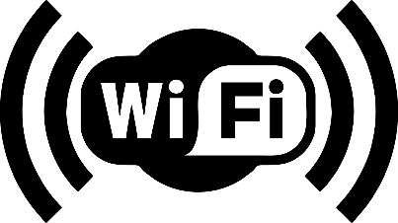 

# 8. ENGINEERING ETHICAL RESPONSIBILITY

**8.1 Public Safety**

* **Design Considerations:**
  + The board was designed to operate safely in extreme environmental conditions, such as high temperatures, vibrations, and exposure to moisture. The enclosure meets IEC 60529 IP66 standards, protecting users and components from environmental hazards.
  + We implemented safety features, such as a Battery Management System (BMS), to prevent risks like overcharging, overheating, or thermal runaway.
* **Real-World Example:**
  + By designing the system to operate reliably between -30°F and 150°F, we reduced the risk of device failure in critical industrial applications, protecting both operators and equipment.

**8.2 Sustainability and Environmental Responsibility**

* **Material Selection:**
  + All components were sourced in compliance with the RoHS directive, eliminating hazardous substances like lead and mercury from the product.
  + Rechargeable 18650 lithium-ion batteries were chosen to minimize waste and reduce the environmental impact compared to disposable alternatives.
* **Battery Recycling:**
  + To address the environmental concerns of lithium-ion battery disposal, we have incorporated long-lasting batteries and included provisions for proper recycling practices.
* **Future Impact:**
  + The board’s modular design allows for easy upgrades and component replacements, extending the product's lifecycle and reducing electronic waste.

**8.3 Data Privacy and Security**

* **Ethical Concern:**
  + The collection and transmission of sensitive environmental and operational data over cellular networks raised potential concerns about data privacy.
* **Design Decision:**
  + We utilized the MQTT protocol with end-to-end encryption to ensure secure data transmission and prevent unauthorized access.
* **Impact:**
  + These measures help protect stakeholder data, ensuring trust and compliance with privacy regulations.

**8.4 Socioeconomic Impact**

* **Efficiency and Cost Savings:**
  + By providing real-time monitoring capabilities, the sensor board reduces downtime and maintenance costs for industries relying on heavy machinery and remote systems.
* **Accessibility:**
  + The board’s compact and modular design ensures that clients can integrate it into existing systems without significant financial or logistical barriers.
* **Stakeholders:**
  + Key stakeholders benefiting from this design include industrial operators, environmental monitoring agencies, and local governments seeking reliable and scalable monitoring solutions.

**8.5 Mitigation of Ethical Conflicts**

* **Environmental Sustainability vs. Cost:**
  + While cost-effective components were considered, we prioritized environmentally sustainable options wherever possible, even at a higher upfront cost.

# 9. SAFETY

**9.1 Electrical Safety**

* **Battery Management System (BMS)**:
  + The integrated BMS ensures safe operation of the **18650 Lithium-Ion batteries**, preventing risks such as overcharging, over-discharging, and thermal runaway.
  + Protection circuits were implemented to handle sudden voltage spikes or drops, safeguarding the board and connected devices.
* **Overcurrent Protection**:
  + Circuitry was designed to prevent excessive current draw, reducing the risk of overheating or damage to components.

**9.2 Environmental Safety**

* **Enclosure Design**:
  + The waterproof ABS plastic enclosure complies with **IEC 60529 IP66 standards**, ensuring protection against dust and powerful water jets.
  + The enclosure was also designed to absorb vibrations and withstand impacts, providing robust protection for internal components.
* **Thermal Performance**:
  + The system was designed to operate reliably within a temperature range of **-30°F to 150°F**. Thermal simulations were conducted to verify heat dissipation and prevent overheating during operation.

**9.3 Safety Testing and Validation**

* **Electrical Testing**:
  + Conducted voltage and current tests to ensure stable power distribution and adherence to design specifications.
  + Verified safety margins for all critical components under simulated extreme environmental conditions.
* **Battery Testing**:
  + Performed stress tests on the battery management system to validate its ability to handle charge cycles safely.
  + Simulated overcurrent and thermal scenarios to ensure safe operation in adverse conditions.
* **Environmental Testing**:
  + Subjected the enclosure to vibration and impact tests to confirm mechanical durability.
  + Conducted moisture ingress tests to validate the enclosure’s waterproofing capabilities.
* **System Failure Response**:
  + Designed the system to alert users of critical failures (e.g., sensor malfunctions or power issues) through the NuvIoT platform, enabling timely intervention.

**9.4 User Safety**

* **Error Notifications**:
  + The board includes monitoring features to notify users of system errors or component failures via cellular communication.
* **Handling Precautions**:
  + Designed with clearly labeled interfaces and protective casing to minimize the risk of accidental electric shock or damage during handling and maintenance.

**9.5 Compliance with Safety Standards**

* **Battery Safety**:
  + Complies with **UL 1642** and **IEC 62133** standards for lithium-ion battery safety, ensuring safe operation in a variety of conditions.
* **Electrical Safety**:
  + Adheres to **IPC-A-610** and **IPC J-STD-001** standards for soldering and assembly, minimizing risks associated with poor connections or faulty components.
* **Ingress Protection**:
  + The design meets **IEC 60529 IP66** standards, ensuring resistance to environmental hazards like water, dust, and physical impacts.

**9.6 Maintenance Safety**

* **Replaceable Components**:
  + The design allows users to replace the battery and sensors safely, with clear instructions to avoid damage or mishandling.
* **Modular Design**:
  + Components can be accessed and replaced without requiring users to interact with high-voltage areas, reducing risk during maintenance.

.

# 10. CONCLUSIONS

The Harsh Environment Sensor Board successfully meets the demands of extreme environmental monitoring by providing a robust, reliable, and scalable solution. Through two design iterations, our team overcame challenges in component integration, environmental resilience, and power management to create a system that operates reliably in temperatures ranging from -30°F to 150°F, withstanding high vibrations and moisture (IP66-rated enclosure). The inclusion of a 4G LTE cellular module and integration with the NuvIoT platform ensures seamless data transmission for real-time monitoring.

This project not only addressed current industrial needs but also laid the groundwork for future advancements in environmental monitoring. By optimizing the board’s design, enhancing communication reliability, and prioritizing safety and sustainability, the Harsh Environment Sensor Board delivers a low-maintenance solution for industries such as manufacturing, energy production, and infrastructure management. Future work could explore extending battery life, incorporating alternative communication protocols, and enabling modular sensor interfaces for broader applications.​

# 11. WORK DIVISION

* Jordan Anger
  + Lead PCB Designer
  + Technical Leader
* Anthony Sedore
  + Software Development
  + PCB Design
* Joseph Portera
  + Team Coordination Leader
  + Safety
* Jasper Everitt
  + Cost and Schedule Leader

# 12. Appendix

*Figure 1: ESP32 and SIM7080G schematics*

*Figure 2: 4v input and power conversion schematic*

*Figure 3: 16 pin connector schematic*

*Figure 4: Lipo Battery and BMS schematic*

*Figure 5: Bill of materials*